**D211 Performance Assessment**

**ADVANCED DATA ACQUISITION FOR MEDICAL DATA**

Fahim A. Akbar Student ID 001434895 Masters Data Analytics (January 1, 2021) Program Mentor: Mandy Rasmuson (801) 891-6865x5957 [fakbar3@wgu.edu](mailto:fakbar3@wgu.edu)

**Part 1: Data Dashboards**

Link to the dashboard: D211 Dashboard -

**A1. Datasets**

The data sets that serve as the data source for my dashboard are “medical_data” and “healthcare_dataset_stroke_data.” **DataSet 1** is represented by the medical_data data set and **DataSet 2** is represented by the diabetic dataset.

Source for “medical_clean”

<https://tasks.wgu.edu/student/001434895/course/23540008/task/2804/overview>

Source for “healthcare_dataset_stroke_data”

<https://www.kaggle.com/datasets/fedesoriano/stroke-prediction-dataset>

**A2. Installation Guide:**

D211Task1.zip file is attached with this submission, as well as a link to the D211Task1.zip file that can be downloaded via Microsoft OneDrive to the virtual machine. The dashboard is provided with the task submission as a .twb file, and can be opened with Tableau reader.

Here is how to install the dashboard on the Labs on Demand Virtual Machine:

* Open the virtual machine. Download the “D211Task1.zip” file provided in this assessment submission, and open File Explorer in the virtual machine. Navigate to ‘C:\Users\Public\Downloads’ (directory) and paste the provided “D211Task1.zip” file to this folder.
* Alternative way to open the file is to download directly through OneDrive with the provided link. Once downloaded, navigate to directory and open the file.
* Download the healthcare-dateaset-stroke-data.csv file from OneDrive. The file is also provided as an attachment with this submission.
* Navigate to pgAdmin in the virtual machine. Expand Servers (1), PostgresSQL 13, Databases (3). medical_data, Schemas (1), public, Tables (7), and finally patient. Right click ‘patient’, select Query Tool and navigate to SQL tab*
* Exit pgAdmin
* Download the “healthcare_dataset_stroke_data.csv” file provided in this assessment submission, and open File Explorer in the virtual machine. Navigate to ‘C:\Users\Public\Downloads’ (directory) and paste the provided “healthcare_dataset_stroke_data.csv” file to this folder.
* Alternative way to open the file is to download directly through OneDrive with the provided link. Once downloaded, navigate to directory and open the file
* Double click on Tableau 2021.4 to launch
* At the top left, click File > Open and navigate to ‘C:\Users\Public\Downloads’. Select the Book1.twb file and open the file

C4: To connect tableau to the medical_data database in Postgres, go to Add connection.

* In the add panel, look under “To a Server” and select the “more” option.
* Under “Installed Connectors” select “PostgreSQL.” Once selected you will be prompted to enter the appropriate information for the fields.
  + For server, enter “localhost” and for port enter “5432.” For the database, enter “medical_data.” For authentication, select “Username and Password.” Once selected, enter your user credentials and then select “sign in.”
* To connect tableau to the healthcare_dataset_stroke_data.csv, go to Add connection.
* In the add panel, look under “To a file” and select the “more” option. Once selected, you will be redirected to the file manager. Here, select the dataset “healthcare_dataset_stroke_data” and click ‘open.’

**A3. Dashboard Navigation:**

* The dashboard is presented as a story divided into three sections:
  + The first section “Cases of Stroke by Gender” focuses on the relationship between gender and likelihood of the stroke
  + The second section “Cases of Stroke by High Blood Pressure” focuses on the relationship between high blood pressure and the likelihood of stroke
  + The third section “Cases of Stroke by Smoking” represents the relationship between smoking and the likelihood of stroke
* To access a section, navigate to and select the respective tab at the top of the screen.
* To toggle between each section, use the arrow keys on the left and right ends of the tabs.
* Beginning with section one, to explore the section select the tile titled “Cases of Stroke by Gender”
* The figures on the left represent data from healthcare_dataset_stroke_data and the figures on the right represent data from medical_data.
* The two tables on the top of the dashboard represent filters that can be used to show only instances of a specific demographic.
* For example, if you only want to see the amount of female patients with stroke from both datasets, you would click on the field that represents the number of patients that are female with “Yes” for stroke, as shown below:
* >provide screens
* To explore section 2, select the tile titled “Cases of Stroke by High Blood Pressure”
* The figures on the left represent data from healthcare_dataset_stroke_data and the figures on the right represent data from medical_data.
* The two tables on the top of the dashboard represent filters that can be used to show only instances of a specific demographic.
* For example, if you only want to see the amount of patients with both stroke and high blood pressure from both datasets, you would click on the field that represents the number of patients that are female with “Yes” for stroke, as shown below:
* >provide screens
* Beginning with section one, to explore the section select the tile titled “Cases of Stroke by Smoking”
* The figures on the left represent data from healthcare_dataset_stroke_data and the figures on the right represent data from medical_data.
* The two tables on the top of the dashboard represent filters that can be used to show only instances of a specific demographic.
* For example, if you only want to see the amount of patients who smoke and have had stroke from both datasets, you would click on the field that represents the number of patients under smoking with “Yes” for stroke, as shown below:
* >provide screens

**A4: SQL code and supporting code:**

Once you’ve connected to the database, you can then begin establishing the dashboard in tableau.

>Go to add

>

*write down how to set up the different graphs and visualizations

Connect the database form pgadmin

To create a bar graph in Tableau, go to Sheet1 and select the two features you want to compare. On the top hand corner select one feature for the columns and one feature for the rows. On the right hand side select the show me menu and select the bar graph option.

Drag gender to filter, drag gender to marks,

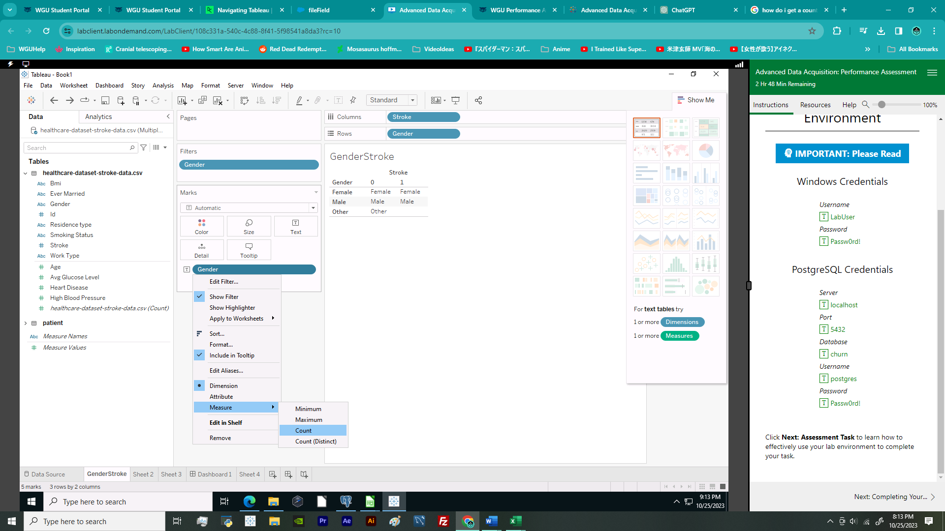

**3. Dashboard Navigation**

>All filters and keys are located on the right-hand side of the dashboard.

**4. SQL code supporting dashboards**

>

**Part 2: Demonstration**

**Panopto Demonstration**

Link to the Panopto Recording:

**Transcript of the presentation:**

Hello, my name is Fahim Akbar and I’m a student at WGU. My undergraduate was in Biology and I am currently pursuing my graduate degree in the WGU MSDA program. I also work as a scientific programmer in a medical center here in Houston, Texas and today I would like to give you all an overview of the demographics of patients with stroke.